8th Asian Virtual Conference on Institutional and Action Research 2026 (8th AVCIAR 2026)
November 26-28, 2026 via ZOOM Teleconferencing

Conference Theme: “Institutional and Action Research for the SDGs:
Innovating Institutions, Transforming Communities, and Sustaining Futures”

DAY 1
November 26, 2026
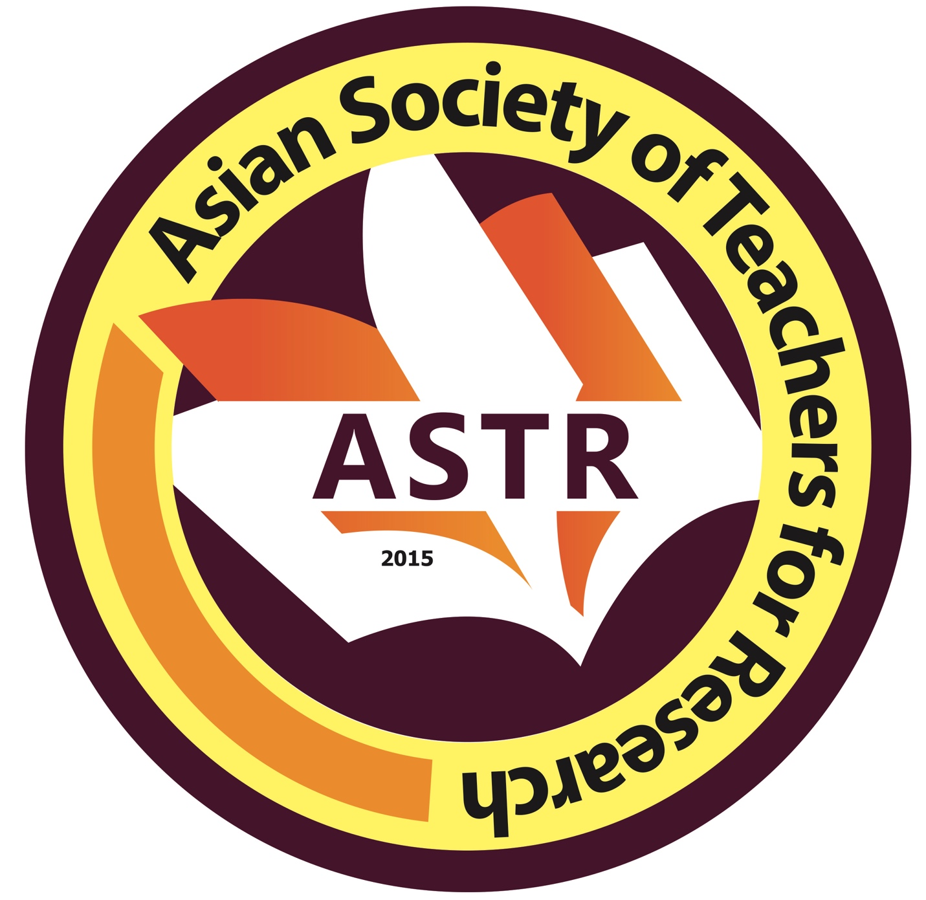
8:01 – 9:00a.m. Registration/Logging In through
ZOOM Teleconferencing

9:01 – 9:10 a.m. Invocation
National Anthem of the Countries Represented

9:11 – 9:20a.m. Opening Remarks and Declaration of the
Opening of the Conference

9: 21 – 9:31 a.m. AVCIAR 2026 Declaration: Synthesis of Abstracts

9:31– 9:35 a.m. Introduction of Keynote Speaker 1

9:36 – 10:00 a.m. Keynote Speech 1

10:01– 10:05 a.m. Introduction of Keynote Speaker 2

10:05 – 10:30 a.m. Keynote Speech 2

10:31– 10:50 a.m. Awarding Ceremony
Best Abstract Award
Best Paper Award
Article Citation Award

10:51-12:00 nn PAPER PRESENTATION

12:00-1:00 p.m LUNCHBREAK

1:01 – 5:00p.m. PAPER PRESENTATION

DAY 2
November 27, 2026

8:01 – 9:00a.m. Registration/Logging In through the ZOOM Breakout Rooms

9:01 – 12:00 nn PAPER PRESENTATION

12:00-1:00 p.m LUNCHBREAK

1:01 – 5:00p.m. PAPER PRESENTATION

DAY 3
November 28, 2026

8:01 – 9:00a.m. Registration/Logging in through ZOOM Teleconferencing
9:01 – 9:10 a.m. Invocation
National Anthem of the Countries Represented

9:11 – 9:20a.m. Introduction of Keynote Speaker

9:21-10:10 am Keynote Speech 3

10:11 – 11:45 p.m. Awarding Ceremonies
Best Oral Presenter Award
Awarding of Certificates to the Participants
Pictorial through ZOOM

ASTR, Inc. Institutional Members



















































